Brady Elementary ACE Fact Sheet
Year 1
Increase Attendance:
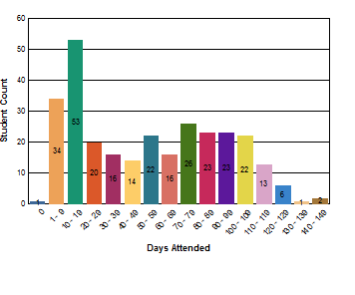

- 162 Regular students (45 days or more) attended the ACE Program. 91 students attended for less than 45 days
- 124 parents/adults attended ACE activities (35 required)

Increase Academic Improvement:

- Reading: 82% of ACE students increased or did not need to increase their grades from fall to spring
- Math: 85% of ACE students increased or did not need to increase their grades from fall to spring

STAAR Results for ACE Students | % Passing for All Students in Campus where center is located | # of ACE Students STAAR Tested | # ACE Students Passing STAAR | % ACE Students Passed
Reading | 65.84 | 120 | 68 | 56.6%
Mathematics | 71.6 | 120 | 80 | 66.6%

Reduce Student Behavior Problems:

Out of Regular Classroom | 2019
Decreased Behavior *(Criminal referrals) | 0
Decreased Behavior * (Non-criminal referrals) | 0

Increase Promotion Rates:

 | 2019
Promotion Rates | 5 ACE Students were retained in their current grade level (Kindergarten; 1st; 2nd)

